Abstract template, Times New Roman with 14-point bold

First A. Author^{1*}, Second B. Author.², Third Author²

¹ “Enzo Ferrari” Dept. of Engineering, Univ. of Modena and Reggio Emilia, Modena (Italy)
² Construction Technologies Institute, National Research Council (CNR), Padova (Italy)
*Corresponding Author: xxx@yyy.com

This guide has been prepared for authors of papers to be presented at the 22nd European Conference on Thermophysical Properties, ECTP2023, to be held in Venice, Italy, on September 10-13, 2023.
Authors are requested to follow these guidelines to achieve uniformity in the presentation. The main format of the paper is as follows. Text: Times New Roman (or equivalent), 11 pt type size, left and right justified. Headings: Times New Roman, 14 pt type size, centered. Page size A4 (210 × 297 mm); 20 mm borders all round except top boarder; paper title starts at 25 mm from top of page. The abstract is transferred to PDF format and is uploaded via www.ectp2023.eu, Submission page. The abstract summarizes key findings in the paper and should be in 1 page. It is also important to indicate briefly the goal, the methods, the results, and conclusions. Follow the format of the references which as listed at the end of the abstract [1-2].

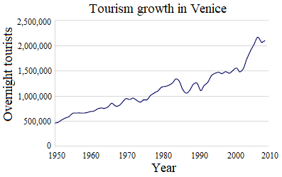
Fig. 1. Use 10 pt Times New Roman for the figure caption, to be placed below the figure.

Table 1. Use 10 pt Times New Roman for the table caption, to be placed above the table.
Case | Data 1 (unit) | Data 2 (unit) | Data 3 (unit)
1
2
3
Acknowledgment
Use this section for the acknowledgment such as the supporting grants, etc.
Significant references
1. F. Pernechele, S. Bobbo, L. Fedele, and R. Stryjek, Int. J. Thermophysics, vol. 30 (2009), pp. 1144-1154.
2. M.J. Assael, A. Chatzimichailidis, K.D. Antoniadis, W.A. Wakeham, M.L. Huber, and H. Fukuyama, High Temperatures–High Pressures, vol. 46 (2017), pp. 391-416.

